# ACTL3143 Assignment: Image Classification of Australian Animals

William Li z5257749

## Problem Specification

The goal of the project is to create a model that can classify between a selection of Australian animals. There are 8 animals in the dataset:

|  |  |  |  |
| --- | --- | --- | --- |
| -Cockatoo  -Kookaburra | -Dingo  -Platypus | -Kangaroo  -Seadragon | -Koala  -Wombat |

Models will be assessed with (Top 1) categorical accuracy.

## Data collection and pre-processing

There are 200 images for each animal. The images were collected from Google Images with the help of the Image Downloader extension. They were selected manually to ensure accuracy and avoid duplicates (though the latter is not guaranteed as I can't perfectly recall 200 images).

All images were rescaled to 128x128, as almost all machine learning techniques require all inputs to be the same size. The data was segmented into 4 sets. Their purpose and number of examples per class are:

* Training (96)
* Validation for early-stopping (32)
* Validation for hyperparameter tuning (32) and
* Test (40)

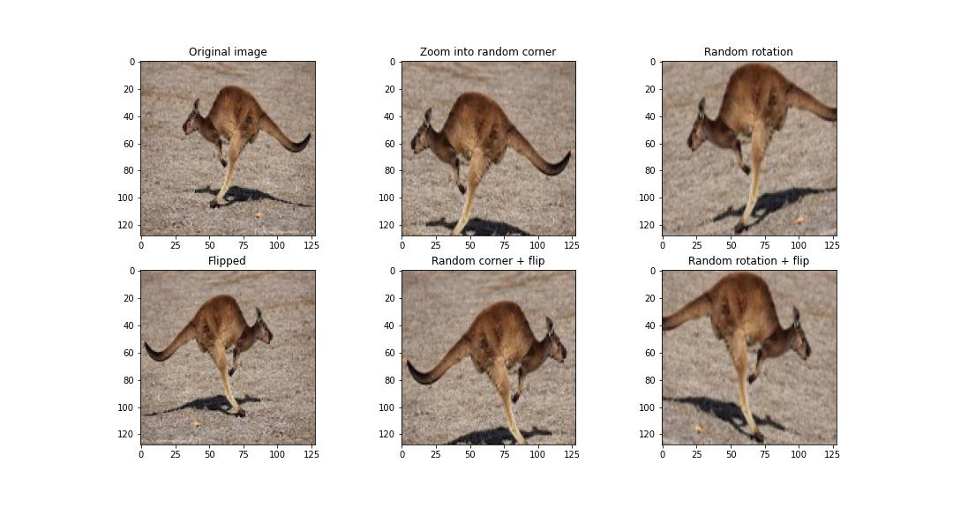The training set was augmented using zoom and rotation to get 6 times as many examples.

## Exploratory Data Analysis

Exploratory data analysis is not as crucial in image classification than in other problems. However, it is helpful to check that the colour channels are working as intended, which can be confirmed based on the photos below. For example, the red channel has low values (represented by dark colour on the “Red Channel”) for the background which is blueish-green, and high values (represented by light colour) for the seadragons coloured orange.

## Simple Benchmark Model: Logistic Regression

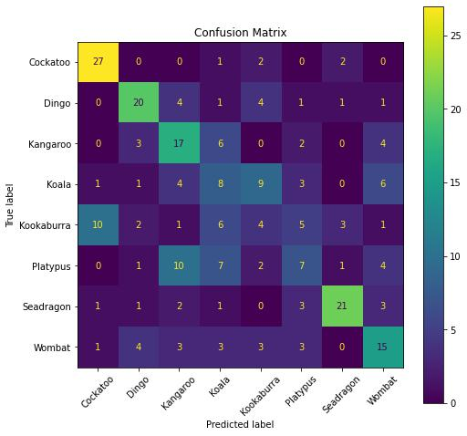Multi-class logistic regression was fit using the multinomial method. All images had to be scaled to 8x8 before fitting as this results in 8x8x3=192 parameters, while having any more parameters than this would result in severe overfitting as logistic regression requires the number of observations to be larger than the number of features. Logistic regression model gave an accuracy of 46.5% in validation set. It is not great but considerably higher than random guessing (which would give an accuracy of 12.5%).

Confusion matrix of logistic regression on validation set. It worked reasonably for some animals but really struggled to identify the koala, kookaburra, and platypus.